**Unit 6: Financial Services – Unit Exam Review**

1. Use the transaction details below to complete a check register. **Use the blank check register on the last page.**

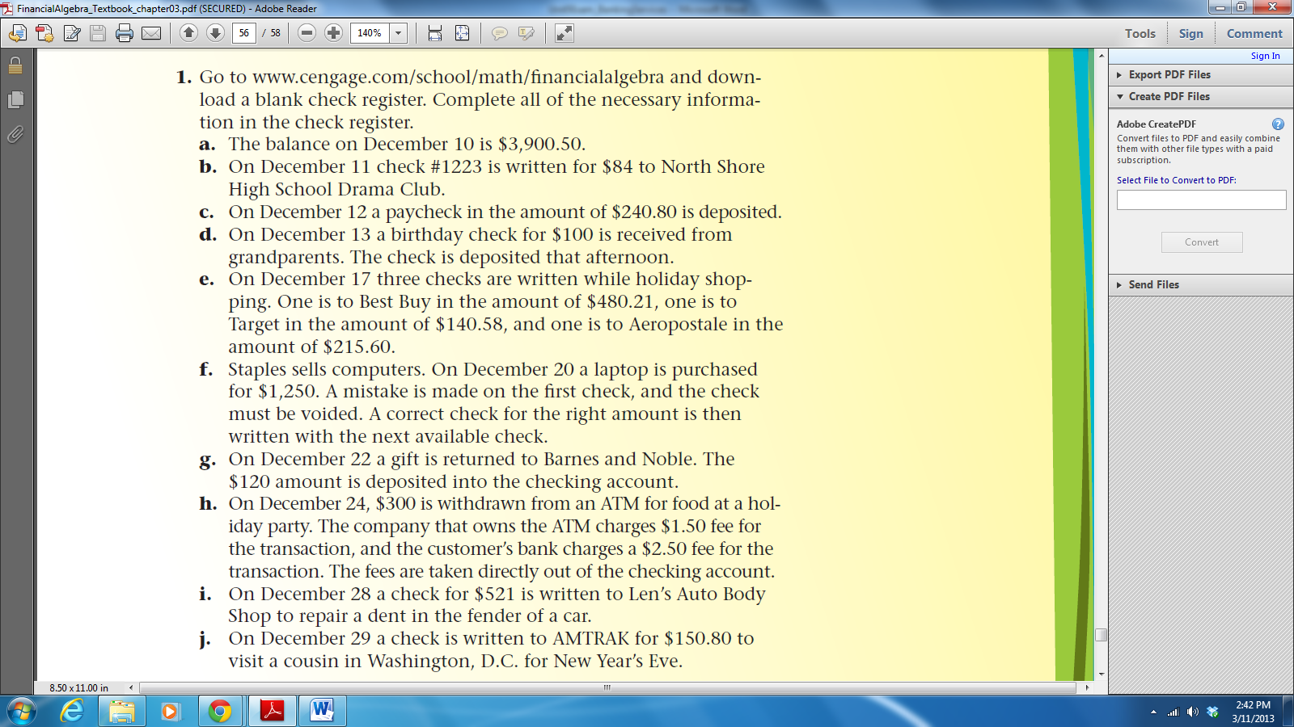

1. Use the check register from the previous problem. It is now one month later and your checking account statement has arrived. Use the statement below to answer questions a – f.

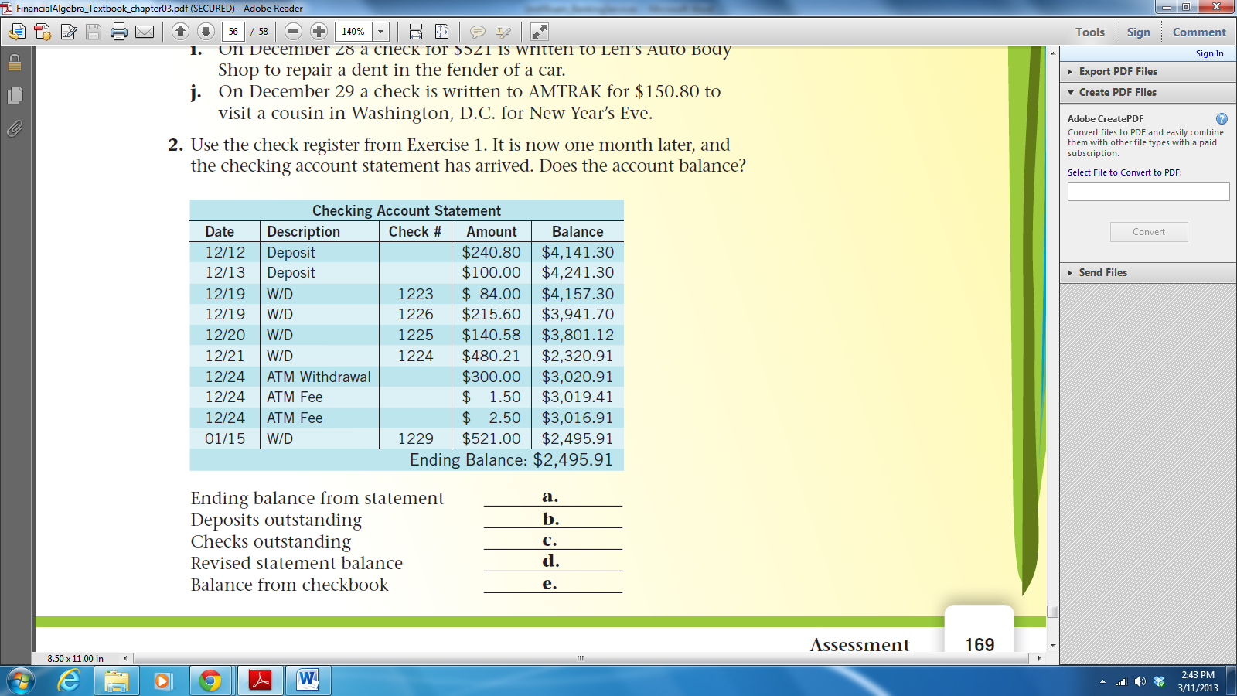

a. Ending balance from statement: $___________

b. + Deposits outstanding: $__________________

c. – Checks outstanding: $____________________

d. = Revised statement balance: $______________

e. Balance from checkbook: $________________

f. Does the account balance? $_______________

1. Find the total simple interest earned on $2,219 principal, after six years at a rate of 5.11%.
2. Ralph deposited $910 in an account that pays 5.2% simple interest for 3 years. Simple interest formula: $I=Prt$
   1. How much **total** interest did the account earn over the whole 3 years?
   2. What is the ending account balance after 3 years?
   3. How much interest did the account earn the first year?
   4. How much interest did the account earn the third year?
3. Rhonda deposits $5,600 in a savings account that pays 4.5 % interest, compounded semiannually. Compound interest formula: $B=P{\left(1+\frac{r}{n}\right)}^{nt}$
   1. What is the account balance after one year?
   2. How much interest did the account earn after one year?
4. Jack deposits $1,000 in an account for retirement that earns 10% simple interest. Jill deposits $1,000 in an account for her retirement that earns 6% interest compounded daily.
   1. Complete the table below comparing the ending balance in each account over time.

|  |  |  |
| --- | --- | --- |
| Time (years) | Jack’s ending account balance | Jill’s ending account balance |
| 0 |  |  |
| 5 |  |  |
| 10 |  |  |
| 15 |  |  |
| 20 |  |  |
| 25 |  |  |
| 30 |  |  |
| 35 |  |  |
| 40 |  |  |
| 45 |  |  |
| 50 |  |  |

* 1. Graph the ending balance of Jack’s & Jill’s account over time.



* 1. Who has earned more money at the end of 5 years? Explain.
  2. Who has earned more money at the end of 50

years? Explain.

1. What is the difference between simple interest and compound interest? Explain.
2. The compound interest formula is below. Explain what **each part** of the formula represents (not the definition of each letter, but what the three distinct parts represent).
$$B=P{\left(1+\frac{r}{n}\right)}^{nt}$$

3. Randy wants to have saved a total of $200,000 in 10 years to buy a house. He is willing to set up a direct deposit account with a 4.5% APR, compounded monthly, but is unsure of how much to deposit each monthly. Use the present value for periodic deposit investments formula to determine Randy’s monthly deposit. $P=\frac{B×\frac{r}{n}}{{\left(1+\frac{r}{n}\right)}^{nt}-1}$
4. Barbara wants to restore her ‘66 Mustang in 4 years. She puts $200 into an account every month that pays 4.5% interest, compounded monthly. How much is in the account after 4 years? Use the future value formula for periodic deposit investments: $B=\frac{P\left[{\left(1+\frac{r}{n}\right)}^{nt}-1\right]}{\frac{r}{n}}$

****Use this check register to complete problem #1.

Answer key

1. See the completed check register on the next page.
2. a. Ending balance from statement: $2495.91

b. Deposits outstanding: $120.00

c. Checks outstanding: $1400.80

d. Revised statement balance: $1215.11

e. Balance from checkbook: $1215.11

f. Does the account balance? YES

1. $680.35
2. a. $141.96

b. $1051.96

c. $47.32

d. $47.32

1. a. $5854.84

b. $254.84

1. (explanations discussed in class)

|  |  |  |
| --- | --- | --- |
| Time (years) | Jack’s ending account balance | Jill’s ending account balance |
| 0 | $1,000 | $1,000 |
| 5 | 1,500 | 1,349.83 |
| 10 | 2,000 | 1,822.03 |
| 15 | 2,500 | 2,459.42 |
| 20 | 3,000 | 3,319.79 |
| 25 | 3,500 | 4,481.14 |
| 30 | 4,000 | 6,048.75 |
| 35 | 4,500 | 8,164.76 |
| 40 | 5,000 | 11,021.00 |
| 45 | 5,500 | 14,876.43 |
| 50 | 6,000 | 20,080.59 |

1. (explanation discussed in class)
2. (explanation discussed in class)
3. $1,322.77
4. $10,496.77