Linear Programming Maximization Quiz #2
Read the scenario below, then answer the questions that follow.

Anderson Cell Phone Company
Anderson Cell Phone Company has started cell phone production. It produces factory smart phones, customizable smart phones, and standard phones. Initially, they hired 10 workers for the assembly line. The workers are paid for 8 hours per day. However, they spend only 7 hours assembling the phones because of a 30-minute lunch break and two 15-minute breaks. A factory smart phone takes 2.5 minutes to assemble, a customizable smart phone takes 3 minutes to assemble and a standard phone takes 1.5 minutes to assemble. The company receives a delivery of 2000 LCD screens, 1000 black cases and 1000 color customizable cases per day from its supplier. Black cases are used for factory smart phones and standard phones. Profit margins for a factory smart phone are $40, for a customizable smart phone are $60, and for a standard phone are $30. Anderson Company is interested in determining the product mix that gives them the highest daily profit.

- Let $x_{1}=$ number of factory smart phones produced daily, $x_{2}=$ number of customizable smart phones produced daily, $x_{3}=$ number of standard phones produced daily.

- Define the objective function: $z=$

- Define the constraints.

Assembly time (minutes):

Screen supply:

Black case supply:

Customizable case supply:

Non-negativity:

- An engineer at Anderson Cell Phone Company used Excel to determine the optimal combination of phones to produce given the company’s current constraints. The answer report is below.
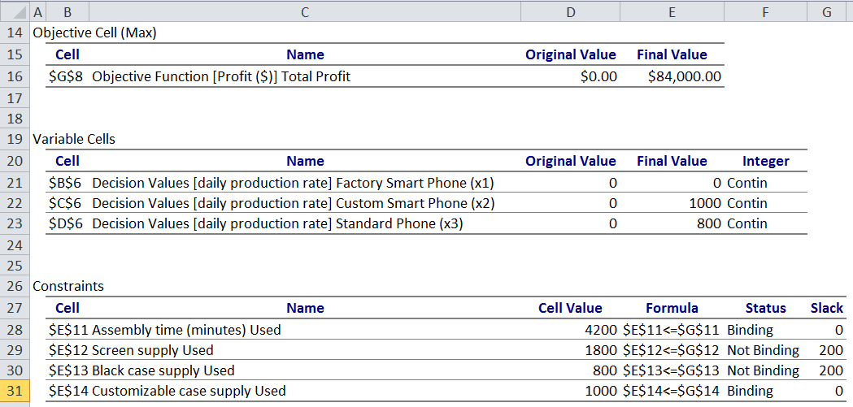

- What is the optimal combination of phones to produce?

- What is the total daily profit earned from this production rate?

- Provide two reasons, using the answer report, why the owner might not be satisfied with this combination.

- The owner of Anderson Cell Phone Company is considering increasing overall production by hiring three more assembly line workers and ordering more supplies for a total of 2500 screens, 1500 black cases and 1000 color customizable cases. The answer report for the optimal combination of phones, given these adjusted constraints, is below.

- What is the new optimal combination of phones?

- What is the new total daily profit?

- Explain whether or not you think Anderson Cell Phone Company should increase its production as outlined above. Consider all three parts of the answer reports in your explanation (“Objective Cell (Max),” “Variable Cells,” and “Constraints”).

