Name _______________________________________________________________ Date _____________________
Homework #1.1 Describing Position in a Distribution
Descriptive Statistics:
Use the data in the table below to answer the following questions:

Quiz scores: | 75 | 100 | 92 | 68 | 88 | 92 | 86

1) Calculate the mean (average) of the data.

2) Find the median of the data.

3) Find the mode of the data.

Graphical Representations:
Use Histograms A & B below to answer the following questions:

Histogram A Histogram B
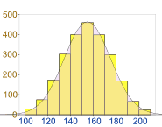
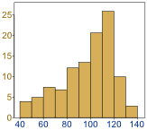

4a,b) Below each histogram, write which type of distribution best describes the data: normal, skewed right, or skewed left

5a,b) Draw a vertical line on each histogram to show the approximate value of the mean (average). Label this line “mean.”

6a,b) Draw a vertical line on each histogram to show the approximate value of the median. Label this line “median.”

7a,b) For each histogram, draw an arrow to the approximate value of the mode. Label this arrow “mode.”

Percentiles:

8) Compute the 30th percentile of the following ordered height data. There are 49 data points. The formula for computing the position of the p^{th} percentile is position= $\frac{p(n+1)}{100}$, where p is the percentile and n is the number of data points.

Height (inches)
60 | 61 | 62 | 62 | 62 | 63 | 63 | 63 | 63 | 64
64 | 64 | 64 | 64 | 64 | 64 | 65 | 65 | 65 | 65
65 | 66 | 66 | 66 | 66 | 67 | 67 | 67 | 67 | 68
68 | 68 | 68 | 68 | 69 | 69 | 69 | 69 | 69 | 69
69 | 70 | 70 | 70 | 70 | 71 | 71 | 72 | 72

For example, the 70th percentile of the data is 69 inches because position= $\frac{70(49+1)}{100}=35$, and the data point in position 35 is 69 inches.

9) On the probability distribution graph below, draw a vertical line to show the approximate value of the 60th percentile.

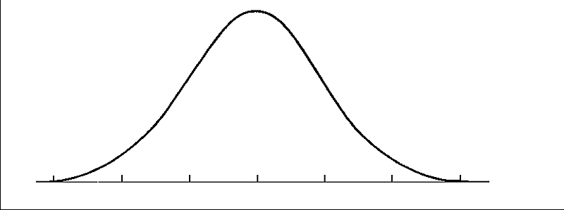
Frequency

Test score

10) A student took the ACT. Her results showed that she received a composite (overall) score of 20, which put her in the 48th percentile. In your own words, explain what it means to be in the 48th percentile.

