AP Statistics FRQ – Probability Rules & Expected Value for Discrete Random Variables
Formulas

2002B Exam FRQ #2

2008 Exam FRQ #3

2004 Exam FRQ #4
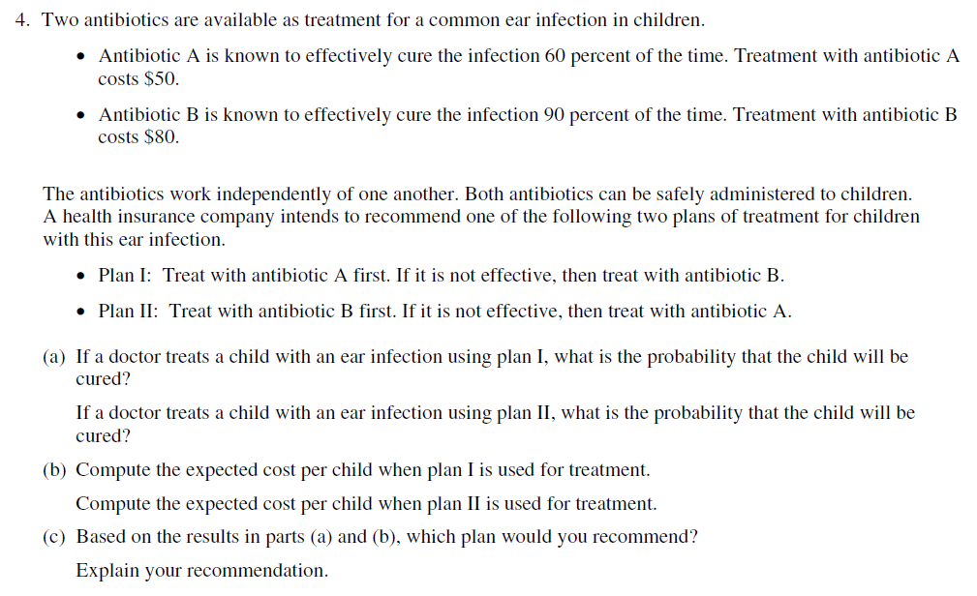

2001 Exam FRQ #2
- Compute the expected cost for a 3-year period if the company purchases Machine A.
Compute the expected cost for a 3-year period if the company purchases Machine B.

- Based on your results in part a), which machine would you recommend?

FRAPPY!
A recent study revealed that a new brand of mp3 player may need to be repaired up to 3 times during its ownership. Let R represent the number of repairs necessary over the lifetime of a randomly selected mp3 player of this brand. The probability distribution of the number of repairs is given below.
$$r_{i}$$ | 0 | 1 | 2 | 3
$$p_{i}$$ | 0.4 | 0.3 | 0.2 | 0.1

a) How often can you expect to repair this brand of mp3 player?
b) Suppose we also randomly select a phone that may require repairs over its lifetime. On average, this brand of phone requires two repairs over its lifetime. Assuming the phone and mp3 player break down independently of each other, how many total repairs should you expect for the two devices over their lifetimes?
c) Each mp3 repair costs $15 and each phone repair costs $25. What is the total amount you can expect to pay in repairs over the life of the devices?

