2.1: Computer Flips, a Junior Achievement Company
2.1.1 Exploring the Problem Writer: _______________________________________
Q1. How much profit will be generated?

Q2. Is there enough installation time available to make that number of each model?

Q3. Answer the same two questions if Gates Williams decides to make:
- 10 Simplex computers and 30 Omniplex computers
Profit:

Installation time:

- 30 Simplex and 10 Omniplex
Profit:

Installation time:

Q4. Find a product mix for which there is enough installation time. Calculate the weekly profit.

Q5. Find two more product mixes for which there is enough installation time. Of the three total product mixes you find, which generates the most profit?

2.1.2 Generalizing the Problem Writer: _______________________________________
Q6. Write an equation for the profit (z) the company would earn in a week. [Hint: look back at Section 2.1.1 and see how you calculated profit for 20 Simplex and 20 Omniplex computers.]

Q7. Write a mathematical statement in terms of $x_{1}$ and $x_{2}$ that describes the relationship between the installation time required and the installation time available. [Hint: look back at Section 2.1.1 and see how you determined if there was enough installation time to produce 20 Simplex and 20 Omniplex computers.]
Q8. Can Computer Flips produce a negative number of either model?

Q9. Write two mathematical statements that describe your answer to the previous question.

2.1.3 A Visual Approach Writer: _______________________________________
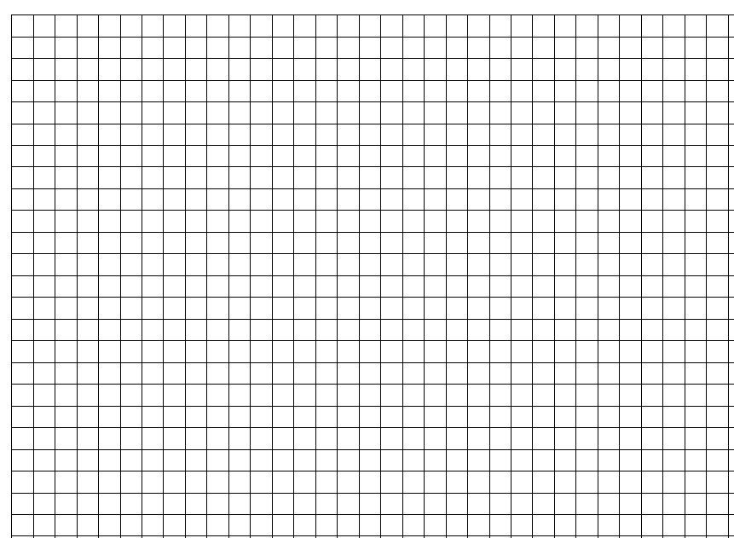
Q10. On the same coordinate axes, graph each of the three inequalities you wrote in the previous section (one from Q7 and two from Q9). For uniformity, place $x_{1}$ on the horizontal axis and $x_{2}$ on the vertical axis. [Hint: you will need to solve the inequality you wrote in Q7 for $x_{2}$.]

Q11. Give one point that satisfies all three inequalities.

.
Q12. Where are all the points that satisfy all three inequalities?

Q13. What is the connection between the points identified in the previous question and the Simplex and Omniplex computers?
Q14. Choose any point in that feasible region, and compute the weekly profit that would be generated by producing that mix of Simplex and Omniplex computers.

Q15. Choose a second point in the feasible region that generates the same weekly profit as the first point. [Hint: you can try to guess & check, or you might find it easier to write the profit equation first, then use it find another point that generates the same weekly profit.]
- Draw a line through the two points on your graph in Q10.
- Write an equation for this line in terms of $x_{1}$ and $x_{2}$.

Q16. Suppose Computer Flips generates $6,000 of profit each week.
- Write an equation to represent this situation.
- Graph this equation on your graph in Q10.

Q17. For each of the following profits, write an equation and then graph that equation (on the same coordinate plane you used for Q10).
- $0 profit

- $3,600 profit

- $4,800 profit

- $7,200 profit

Q18. What do you notice about the six lines you have drawn in Q15, Q16 and Q17?

Q19. Which of the lines generates the largest weekly profit?

Q20. If you were to continue drawing lines this way, where does the line that generates the largest weekly profit intersect the feasible region? What is the profit at that point?

2.1.4 Solving the Problem Writer: _______________________________________
Q21. Choose a point on the boundary of the feasible region, but not at a corner (vertex), and evaluate the profit there.

Q22. Continue to choose points on the boundary, but try to increase the amount of profit each time. Show your profit calculation for two of the points you tried.

Q23. Finally, evaluate the profit at each of the corner points of the feasible region.

Q24. What is the relationship between the corner points and the feasible region?

Q25. At which of these points is the profit the greatest? How would you describe this point? Recall: The point at which profit is maximized is called the optimal solution.

Q26. There is not always one optimal solution. Draw an example of a feasible region that could have more than one optimal solution.

2.1.5 Complicating the Problem Writer: _______________________________________
Q27. Write an inequality that expresses this market constraint.

Q28. Graph the new system of constraint inequalities.

Q29. What do you notice about the optimal solution you found earlier?

Q30. What is the optimal solution after adding the market constraint?

Q31. Write an inequality for this new market constraint.

Q32. Graph the new feasible region.

Q33. Does the previous optimal solution lie in the new feasible region?

Q34. What is the optimal solution after the addition of the second market constraint?

Q35. Write an inequality for testing a constraint based on the information in the previous paragraph.

Q36. Graph the new feasible region.

Q37. Using the new feasible region, what is the optimal solution?

Q38. Why is it possible to have a non-integer solution?
2.1.6 Success Breeds – An Even More Complicated Problem Writer: __________________________
Q39. What are the decision variables in the new problem? What do they represent?

Q40. Write an equation for the profit (z) the company would earn in a week.

Q41. Using the information above, formulate the constraints after the Multiplex and Megaplex models have been added to the product mix.

Q42. Is it possible to solve this problem by graphing? Why or why not?

